Uploading Videos using WeTransfer.com
WeTransfer.com allows you to upload files up to 2 GB free without creating an account.

Open a web browser and type in https://wetransfer.com/
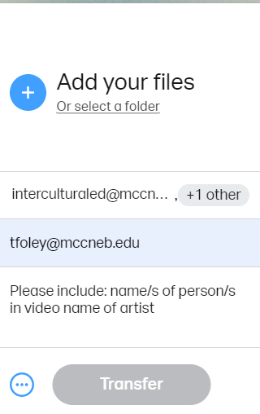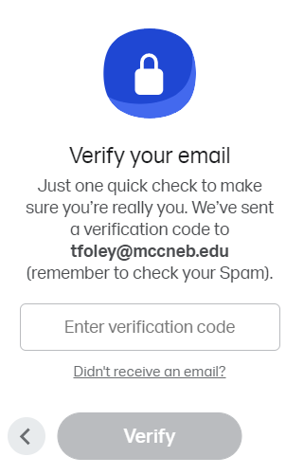

You can upload files in a similar fashion using your android or iPhone web browser.

If you have any questions or require technical assistance, please contact Theresa Foley at tfoley@mccneb.edu or 531-622-2266, 8:00 a.m. to 5:00 p.m.

