**Make sure when submitting exams, you are following Test Center guidelines**
Open the Testing Center Transmittal page: https://apps.mccneb.edu/MakeupExamFaculty/Default.aspx
You will have to enter your MCC log in credentials.
You can submit either a paper version of your exam if you want it printed or you can submit an electronic version of your exam if the exam is to be done and submitted online.

Submit Paper Exam
- Choose the ‘Submit Paper Makeup Exam’ option.
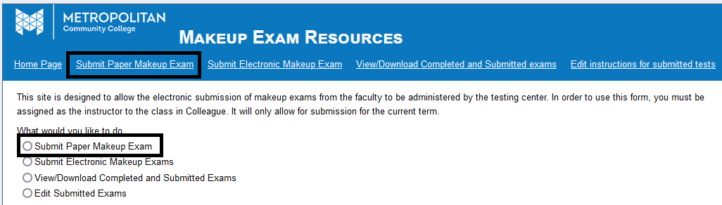
- From the Section drop-down menu, choose your class that the test is for.
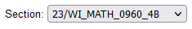
- Enter your Preferred method of contact followed by an alternate method of contact, one will be your email and the other will be a phone number (must be typed in the format xxx-xxx-xxxx).
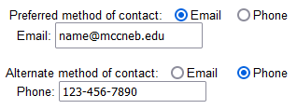
- Type in what campus/location you would like this printed exam to be returned (ex: FOC 023).
- Type in a time limit IN MINUTES (ex: if 2 hour time limit, type in 120).

- Type in the deadline date (in the format MM/DD/YYYY) followed by the deadline time (in the format HH:MM AM/PM, such as 11:00 AM).
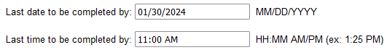

- Select from the given list, what materials (if any) are allowed (‘None’ is an option).
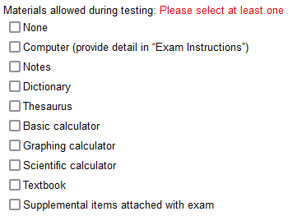
- Type in a name for your Exam (ex: MATH 0960-4B Exam 1). Make sure the name is specific enough so that if you submit multiple exams that you know which is which.
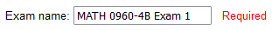
- In the Exam Instructions, type in any special instructions you would like your student would do that the Test Center could tell the student.
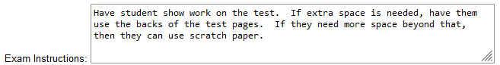

- Click the Exam Browse button to upload the exam document you would like the Test Center staff to print and give to your student to complete.
- Click the optional Attachment Browse button to upload any supplementary materials you would like the Test Center staff to print that the student can use during the exam. (If you plan on using this option, make sure ‘Supplemental items attached with exam’ is chosen in the Material checklist.)
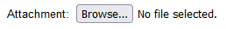

- From the provided list, select which students will need to take your exam. If any students need individual instructions that are different from everyone else (such as DSS accommodations), they can by typed in next to their name.
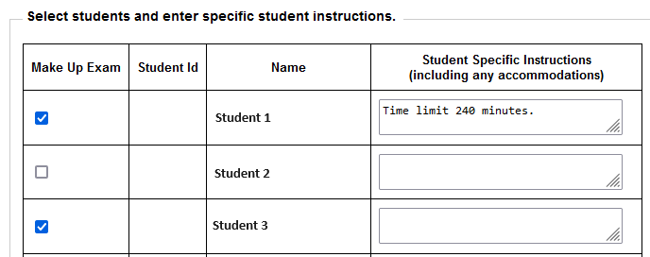
- Click Submit to finalize (or Clear All Fields in you want to start over).
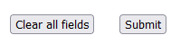

Submit Electronic Exam
- Choose the ‘Submit Electronic Makeup Exam’ option.
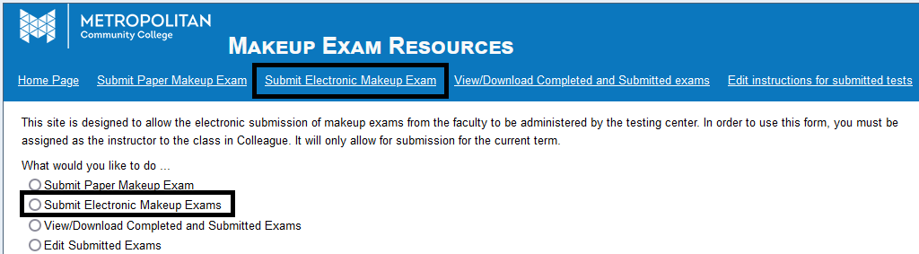
- From the Section drop-down menu, choose your class that the test is for.
- Enter your Preferred method of contact followed by an alternate method of contact, one will be your email and the other will be a phone number (must be typed in the format xxx-xxx-xxxx).
- Type in what campus/location you would like this printed exam to be returned (ex: FOC 023).
- Type in a time limit IN MINUTES (ex: if 2 hour time limit, type in 120).

- Type in the deadline date (in the format MM/DD/YYYY) followed by the deadline time (in the format HH:MM AM/PM, such as 11:00 AM).

- Select from the given list, what materials (if any) are allowed (‘None’ is an option).
- Type in a name for your Exam (ex: MATH 0960-4B Exam 1). Make sure the name is specific enough so that if you submit multiple exams that you know which is which.
- In the General log-on information and Exam Instructions box, type in how the student is to access their online exam and any special instructions you would like your student would do that the Test Center could tell the student.
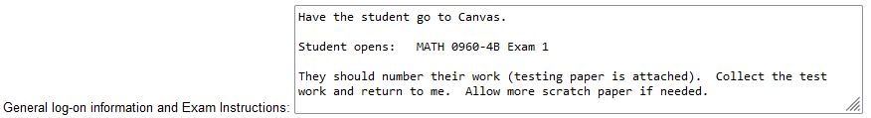

- Click the optional Attachment Browse button to upload any supplementary materials you would like the Test Center staff to print that the student can use during the exam. (If you plan on using this option, make sure ‘Supplemental items attached with exam’ is chosen in the Material checklist.)

- From the provided list, select which students will need to take your exam. If any students need individual instructions that are different from everyone else (such as DSS accommodations), they can by typed in next to their name.
- Click Submit to finalize (or Clear All Fields in you want to start over).

View/Download Completed and Submitted Exams
When a student completes an exam, the Test Center staff will scan the exam/file and upload to this site as well as mail the hard copies to your desired mailing location that you inputted when you submitted the exam.
- Click the ‘View/Download Completed and Submitted Exams’ option.
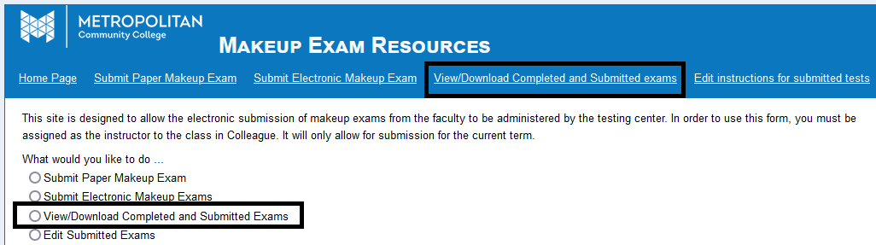
- From the Section drop-down menu, choose your class that the test is for.
- A list of files submitted for this class will be shown (exams if Paper Exam was submitted, attachments if Electronic Exam was submitted). If the Exam Taken Date, Testing Center Notes, and Exam Upload Date columns are filled in, then the student has completed the exam/file and you can now download the scanned copy of their completed exam/file by clicking the ‘View Instructions/Download Files’ button. If these columns are blank, then the student has not completed that exam, but you can still see the file and instructions you submitted by clicking the ‘View Instructions/Download Files’ button.

Edit Instructions for Submitted Tests
If you need to make any changes to your exam instructions, and the student has not yet completed the exam, you can do so.
- Click the ‘Edit instructions for submitted tests’ or ‘Edit Submitted Exams’ option.
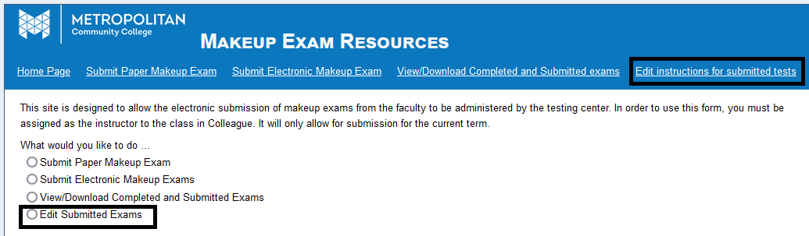
- From the Section drop-down menu, choose your class that the test is for.
- From the Test Name drop-down menu, choose the exam you would like to edit (this is why it is important to be specific when naming the exam).
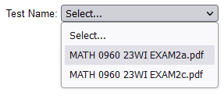
- Make changes as necessary.

