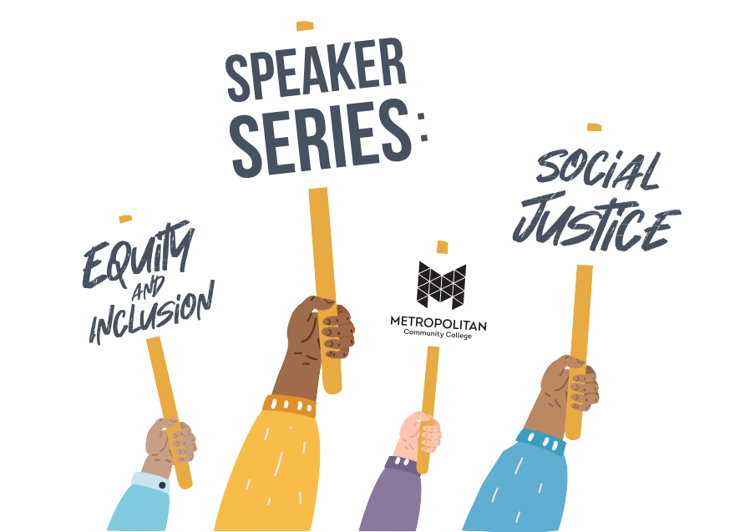

**Metropolitan Community** **College**

**Office of Equity** **and Inclusion Presents….**

Fall 2021 Equity and Inclusion Speaker Series

October 1, 2021, 10:00 a.m.-noon via ZOOM

**Please Register on the MCC Training and Development web page**

**“Equity Mindedness in College Advising”**

Featured Presenter: Mr. Trent Ball

