BAXTER ARENA & MAVERICK PARK | PRESS RELEASE
Limited Parking Around Baxter Arena on Friday, May 20
Omaha, NE (May 19, 2022) --
On Friday, May 20, Baxter Arena and Maverick Park will host the Metropolitan Community College Commencement Ceremony and the NSAA State Baseball Championship for Class B, respectively. With these events scheduled to coincide on Friday evening, parking will be at a premium. Guests are encouraged to carpool and arrive early to allow additional time for traffic and parking.
Parking is free and spaces are first come, first served at Baxter Arena and Maverick Park. Additional parking is located in the Aksarben Village parking garages.
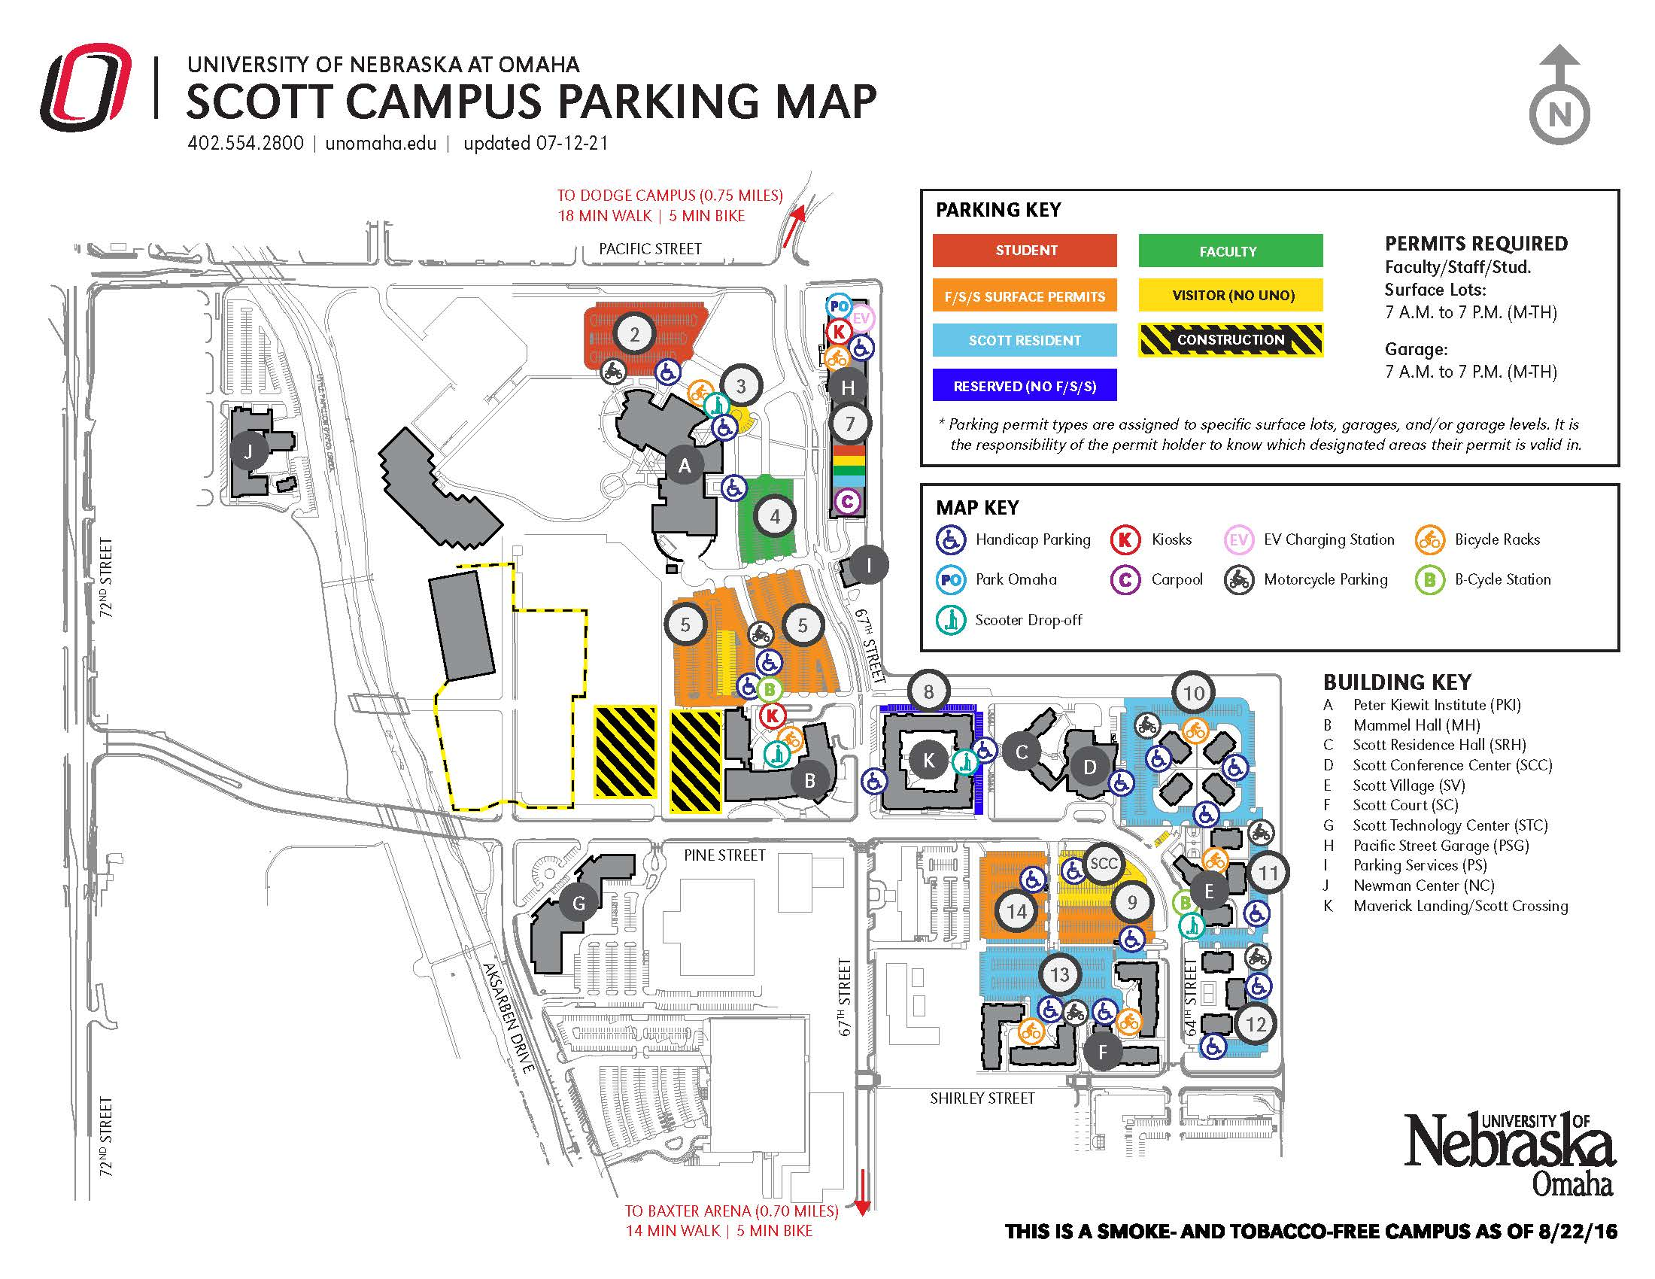
Additionally, Baxter Arena has set up a shuttle service from UNO’s Scott Campus parking lots 4 & 5 located by Mammel Hall to Baxter Arena. The shuttle service will operate from 5:30 p.m. to 10:30 p.m. on Friday.
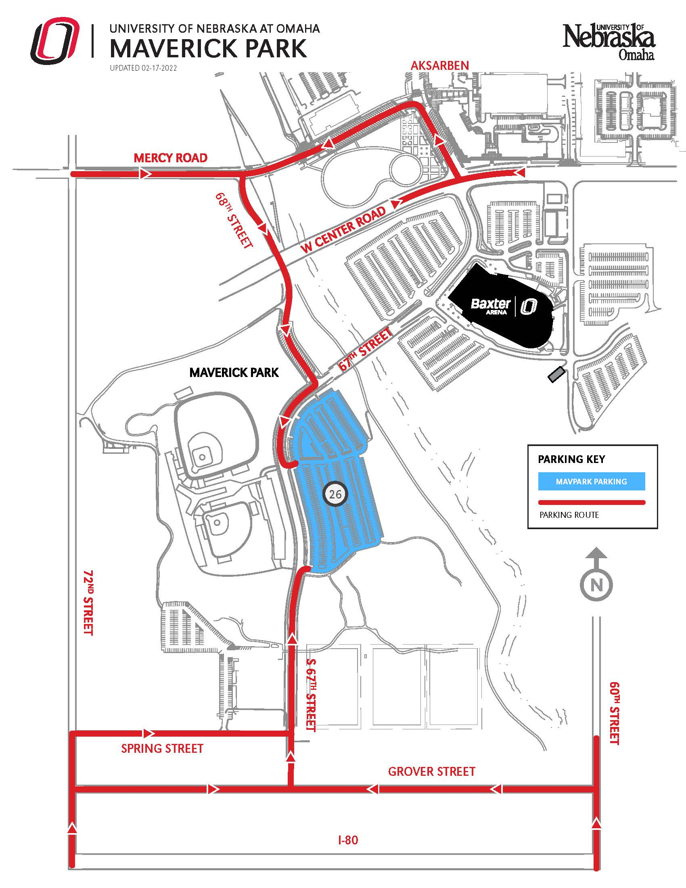
Friday Schedule:
- Class B NSAA State Baseball - Skutt Catholic vs. Elkhorn North
  - 4:00 p.m. | Tal Anderson Field
- Class B NSAA State Baseball - Waverly vs. TBD
  - 7:00 p.m. | Tal Anderson Field
- Metropolitan Community College Commencement Ceremony
  - 7:30 p.m. | Baxter Arena

