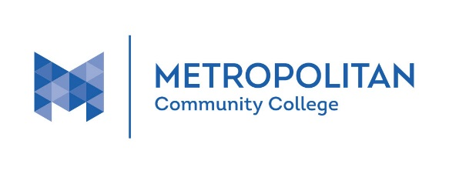
Adult Education Program Locations

Location | Address | ESL | GED
Bellevue University | 1000 Galvin Road South, Bellevue
DO Space | 7205 Dodge St.
Fort Omaha Campus | 5300 N. 30th St.
Fremont Area Center | 835 N. Broad St., Fremont
Heartland Workforce Solutions | 5752 Ames Ave.
MCC Express-South | 3002 S. 24th St.
Millard Central Middle School | 12801 L St.
Millard South High School | 14905 Q St.
Ralston Middle School* | 8202 Lakeview St., Ralston
South Omaha Campus | 2909 Edward Babe Gomez Ave.
Spring Lake Magnet School* | 4215 S. 20th St.
New Location: MCC Express-North | 2113 N 30th Street
* no classes during summer months at these locations

