The first time you login to Okta, you will be prompted to create your MCCNEB account in Okta.
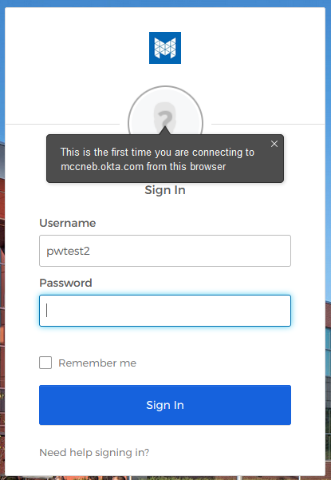

You will need to setup the following in order to reset your password and/or unlock your account:
- Enter a secondary email address (DO NOT your MCC email address) or select I don’t have a secondary email option
- Choose a security question and enter an answer
- Enter a mobile phone number for SMS (text message) if you wish to use this option
- Enter a phone number for Voice Call if you wish to use this option
- Choose a security image
You can use the same phone number for SMS and Voice Call.
Once you have entered all the information, click the Create My Account button.
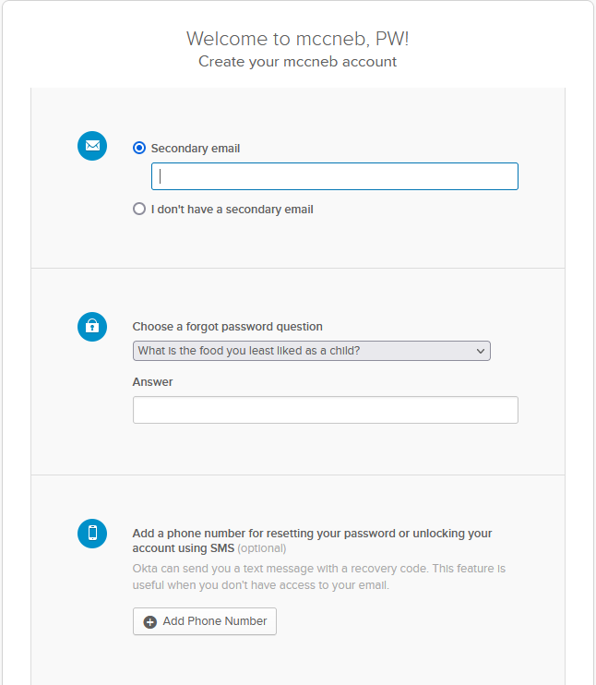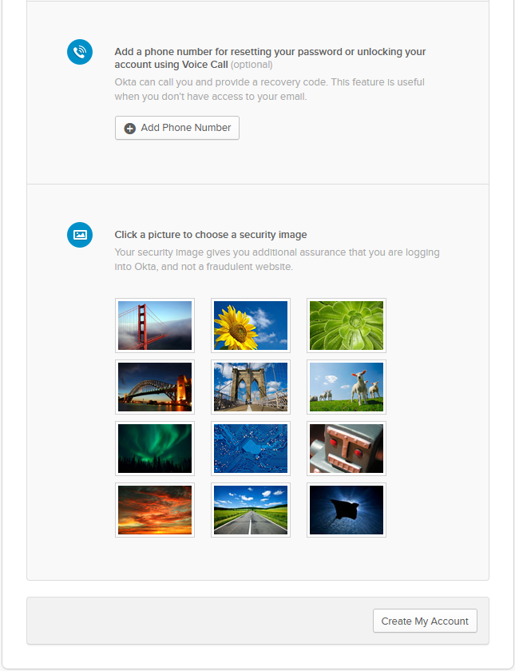

Here is the list of forgot password security questions to choose from:
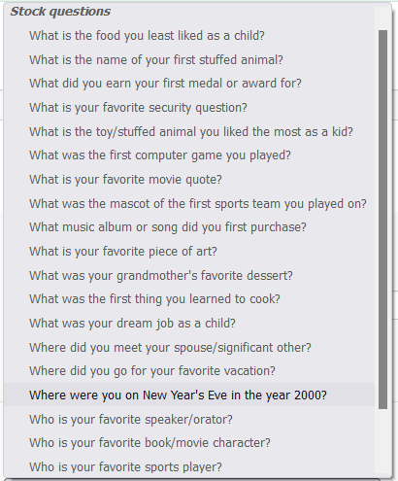
Be sure to provide an answer you will remember as you will need to answer this question correctly in order to reset your password or unlock your account.

When you provide a phone number for resetting your password or unlocking your account using SMS (text message), you will see the following:
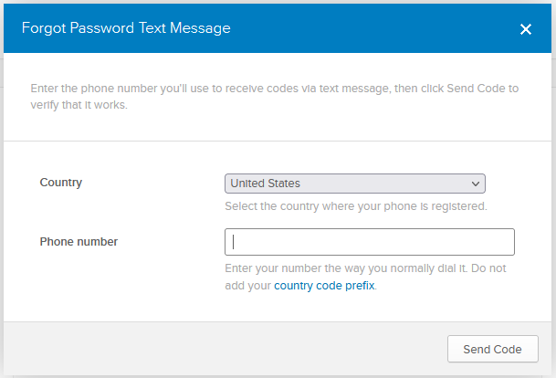
Enter your mobile phone number and click Send Code. You will then receive an automated text message with a 6-digit verification code that you will need to enter in the following screen and click Verify:
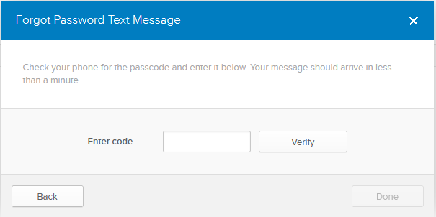
Once you have successfully verified your mobile number, you will be prompted to click Done.

When you provide a phone number for resetting your password or unlocking your account using Voice Call, you will see the following:
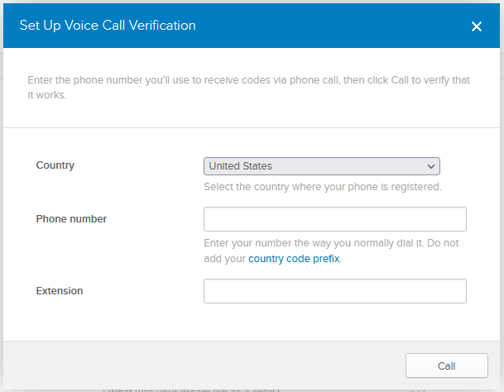
Enter your phone number and click Call. You will then receive an automated phone call from 872-278-8883 (a Chicago, IL phone number) with a 5-digit verification code that you will need to enter in the following screen and click Verify:
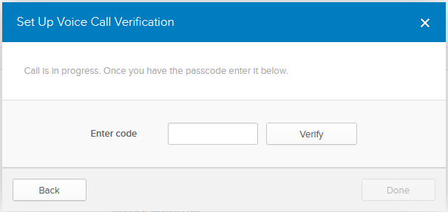
Once you have successfully verified your phone number, you will be prompted to click Done.
When providing a secondary email address to use to reset your password and/or unlock your account, you will need to verify this secondary email account before you will be able to use it. You will receive an email in your secondary email Inbox from Okta (noreply@okta.com). Click the Confirm Email Change button in this email in order to verify your secondary email address.
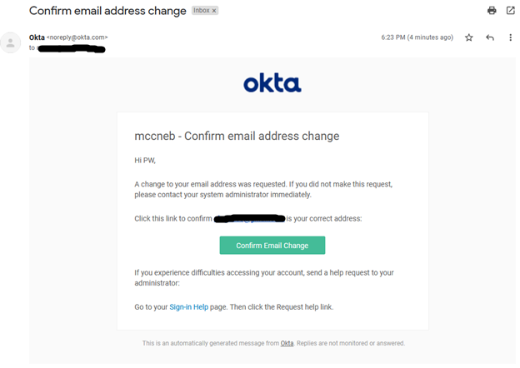
Clicking on this button will take you to an Okta login screen where you will need to enter your username and password (if you are not already logged into Okta). Once your credentials have been correctly entered, you will see the following screen showing your secondary email address has been successfully verified:
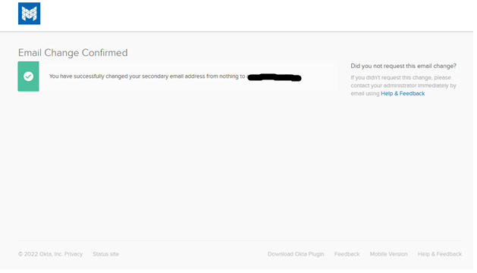
You can close this window.

CHANGING OR UPDATING ENROLLMENT INFORMATION:
If you need to change or update any of these settings after initial configuration, login at https://myapps.mccneb.edu and click the dropdown arrow in the upper right corner next to your name:
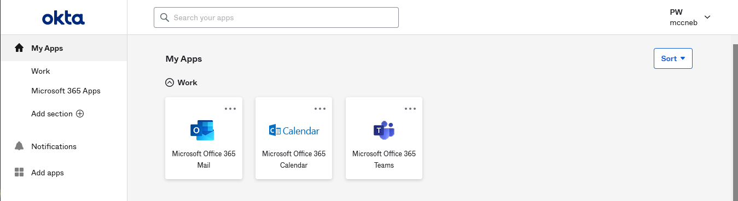
On the popup menu, click Settings.
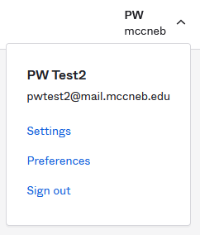

Click the Edit button next to the section containing the information you would like to change or update:
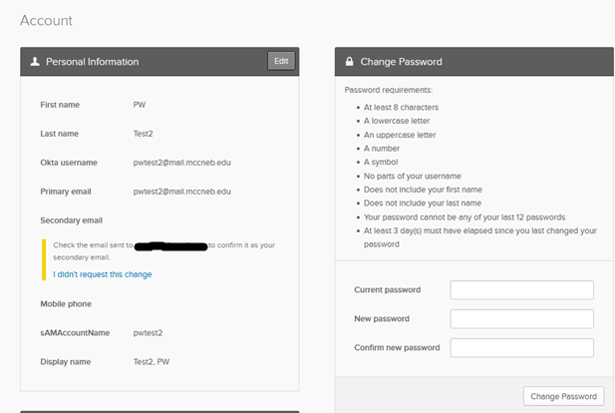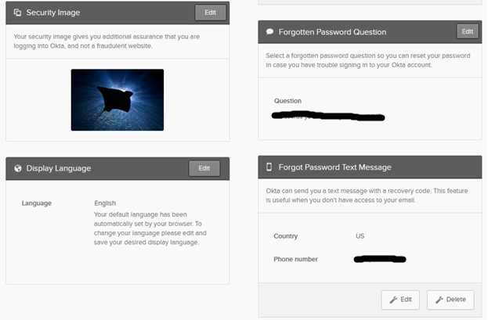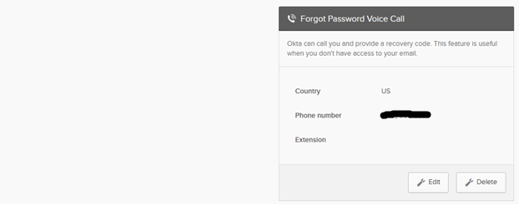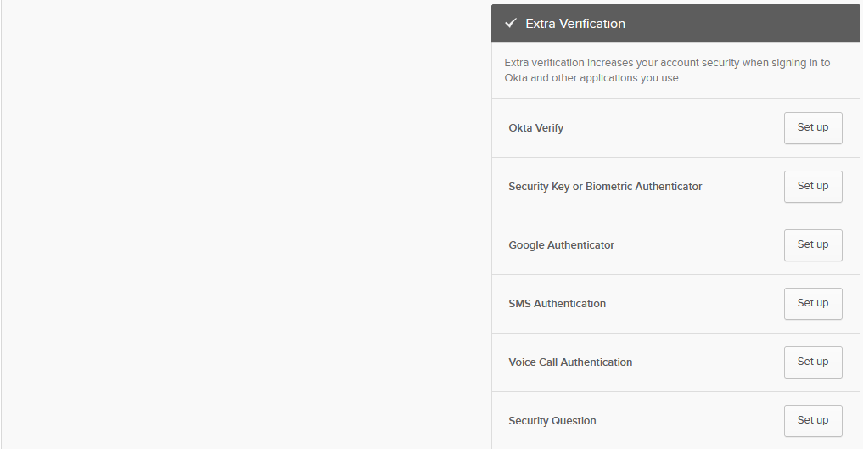

**NOTE** If you see the following notice instead of your Secondary email address listed under Personal Information, you still need to verify your secondary email address before you will be able to use it. Login to your secondary email account, find the email from Okta (noreply@okta.com), and follow the directions previously described in order to verify your secondary email address.
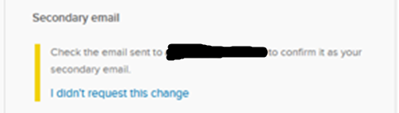

If you see your secondary email address listed, you have properly verified it and it is ready for use.
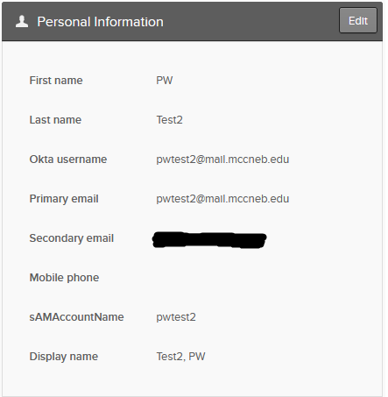

If you choose, you can setup Extra Verification on your account. If you choose to setup this additional verification, go to the Extra Verification section, select the Set up button next to the type of verification you wish to add, and follow the on-screen steps to configure.

