Request to Reissue Diploma
Instructions:
Students who have misplaced or lost their diploma may request to have a new one issued. A Request to Reissue Diploma form needs to be completed either in person or via mail. If a name change is requested on the diploma, the student must also complete a Name Change Request form, along with required documentation (see Procedure to Request to Change Name on Diploma or Certificate Records Office webpage,https://mccneb.edu/getattachment/Prospective-Students/Resources/Student-Services-SOS/Records/Request-to-Change-Name-on-Diploma/NameChangeRequestForm.docx.aspx).

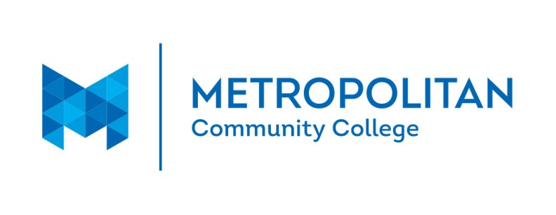

REQUEST FOR REISSUE OF A DIPLOMA
Name: |  |  |  |  |  |  |  |  | MCC ID
 | Type your name as you want it to appear on your diploma
Address:
 | Street Address |  |  |  |  | City |  |  | State |  |  | ZipCode
Home Phone: |  |  |  | Work Phone:

I, |  |  | am requesting that a diploma be reissued to me.
Full Name
The reason for requesting a replacement diploma is:

Date original diploma was issued:
Program of Study:
Type of Diploma: |  | Certificate of Achievement
 |  | Associate Degree
 |  | Specialist Diploma

Replacement diplomas will be noted “REISSUE” with the reissue date.

Student Signature_____________________________________________ Date

ALL REQUESTS ARE SUBJECT TO APPROVAL
For Office Use Only

______ Approved _____ Denied (reason) __________________________________

____________________________________________ ________________________
Registrar Date

____________________________________________ _______________________
Records Project Assistant Mailed Date

Metropolitan Community College Records Office
P O Box 3777 FOC Bldg 5 Omaha, NE 68103-3777

